|LAB- ASSIGNMENT-4.1|

TASK-1

## Task #1 – Zero-Shot Prompting with Conditional Validation

## Objective

## Use zero-shot prompting to instruct an AI tool to generate a function

## that validates an Indian mobile number.

## Requirements

## • The function must ensure the mobile number:

## o Starts with 6, 7, 8, or 9

## o Contains exactly 10 digits

## Expected Output

## • A valid Python function that performs all required validations

## without using any input-output examples in the prompt.

# CODE :

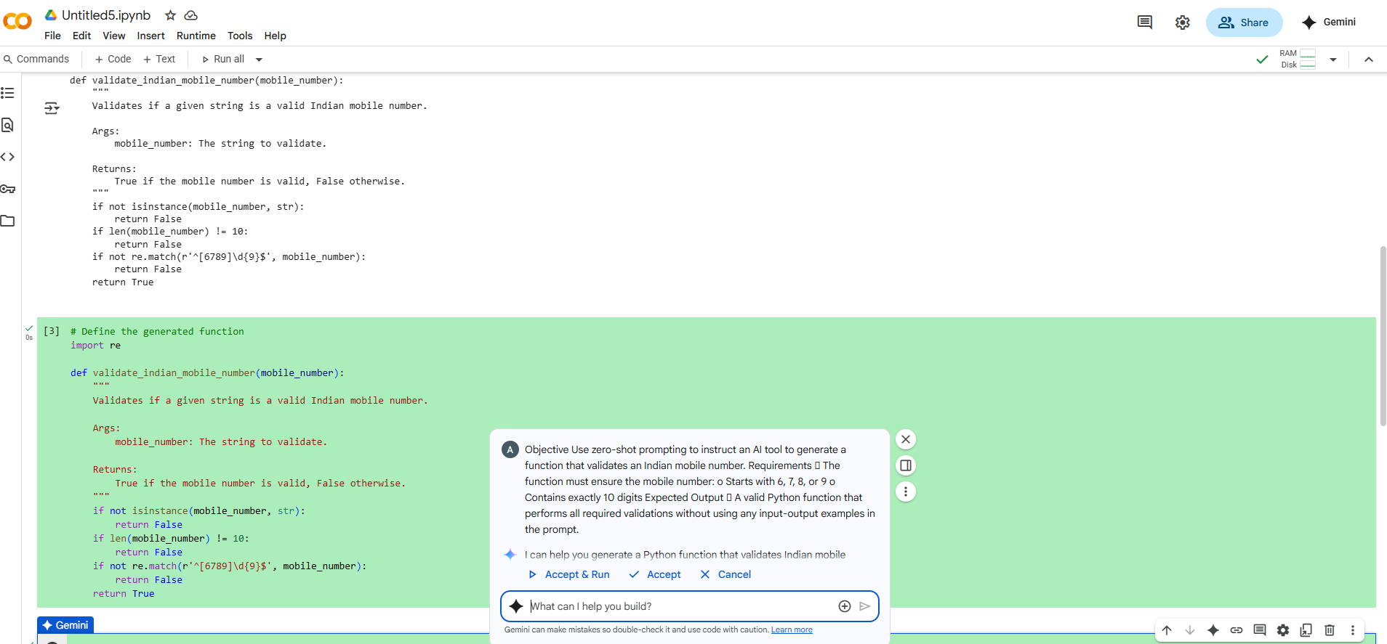

TASK-2

Task #2 – One-Shot Prompting with Edge Case Handling

Objective

Use one-shot prompting to generate a Python function that calculates

the factorial of a number.

Requirements

• Provide one sample input-output pair in the prompt to guide the

AI.

• The function should handle:

o 0! correctly

o Negative input by returning an appropriate message

Expected Output

• A Python function with correct factorial logic and edge case

handling, generated from a single example.

# CODE:

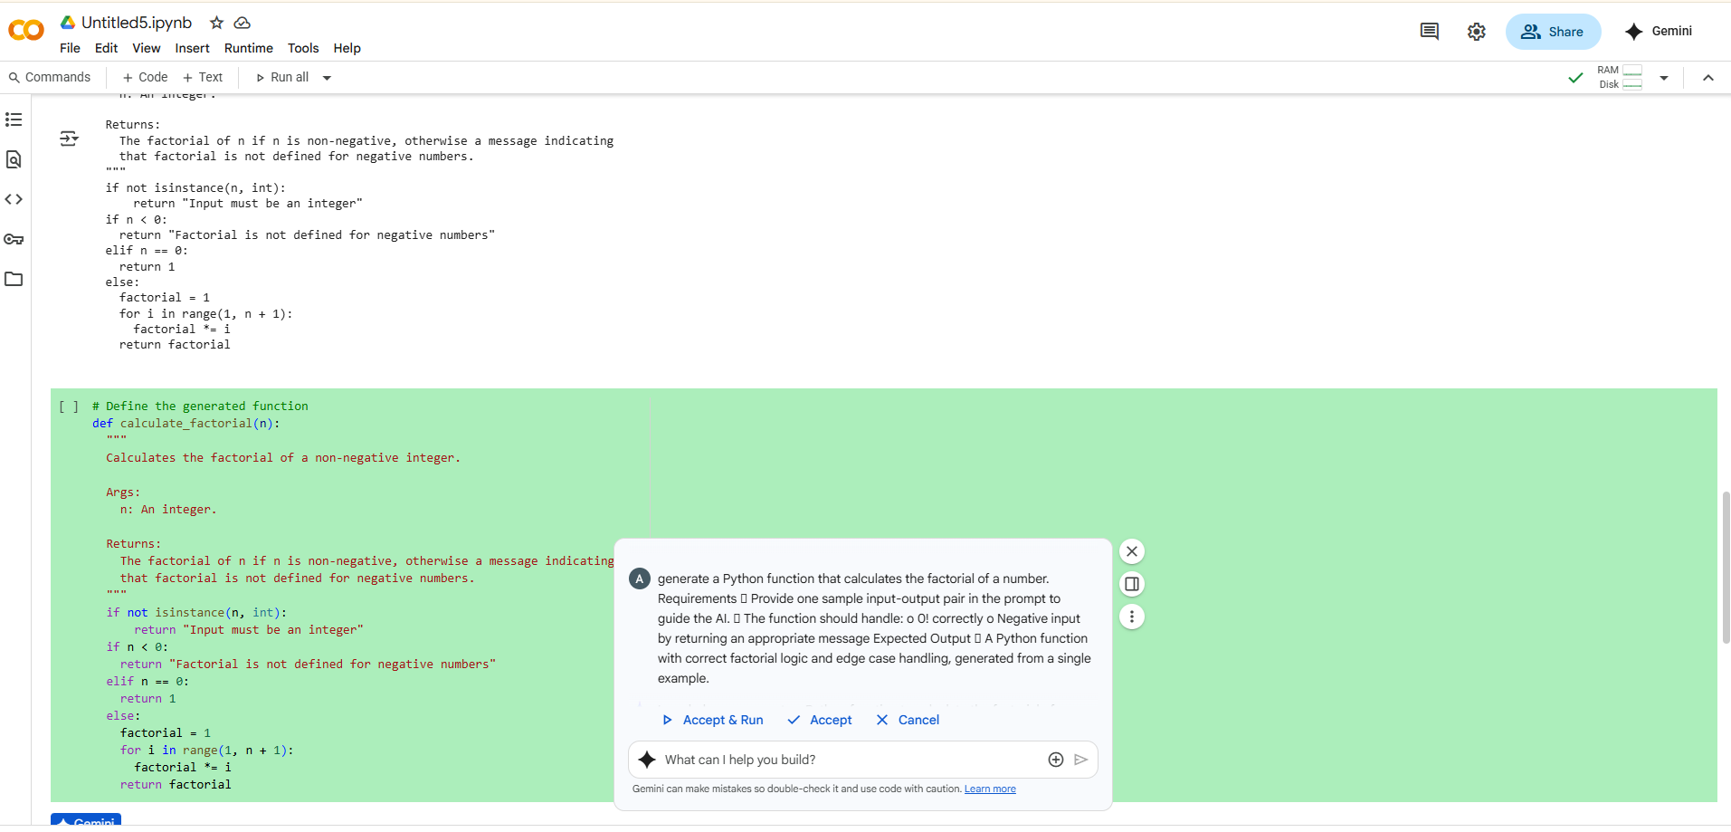

TASK-3

Task #3 – Few-Shot Prompting for Nested Dictionary Extraction

Objective

Use few-shot prompting (2–3 examples) to instruct the AI to create a

function that parses a nested dictionary representing student

information.

Requirements

• The function should extract and return:

o Full Name

o Branch

o SGPA

Expected Output

• A reusable Python function that correctly navigates and extracts

values from nested dictionaries based on the provided examples.

### CODE:

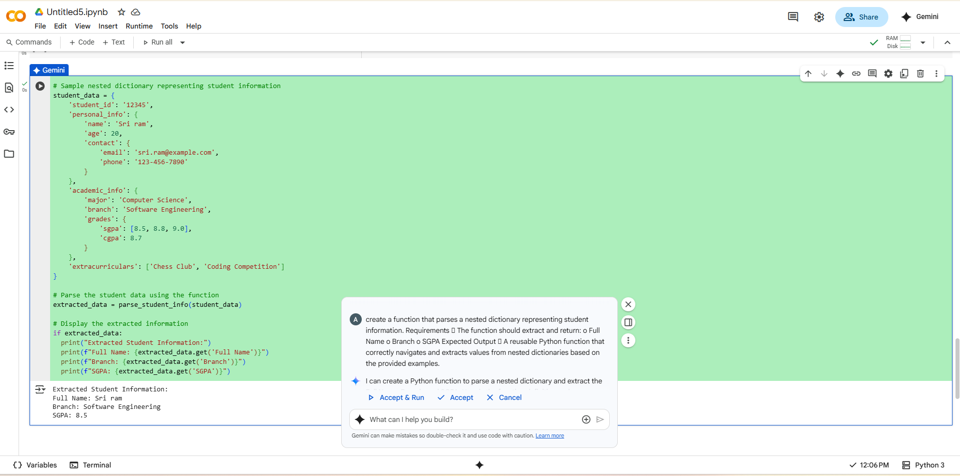

TASK-4

Task #4 – Comparing Prompting Styles for File Analysis

Objective

Experiment with zero-shot, one-shot, and few-shot prompting to

generate functions for CSV file analysis.

Requirements

• Each generated function should:

o Read a .csv file

o Return the total number of rows

o Count the number of empty rows

o Count the number of words across the file

Expected Output

• Working Python functions for each prompting style, with a brief

reflection comparing their accuracy, clarity, and efficiency.

### CODE:

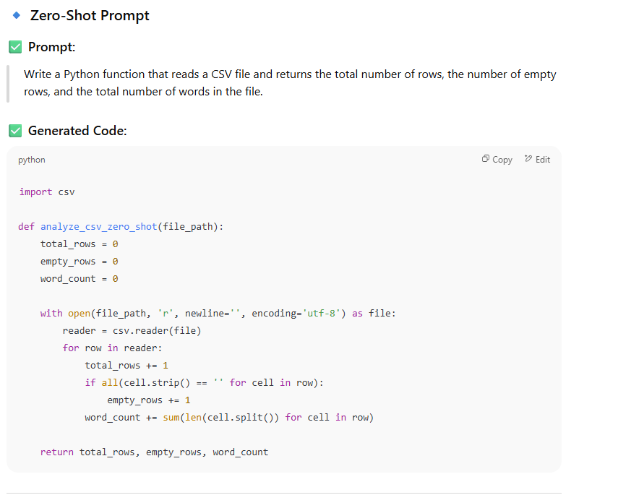

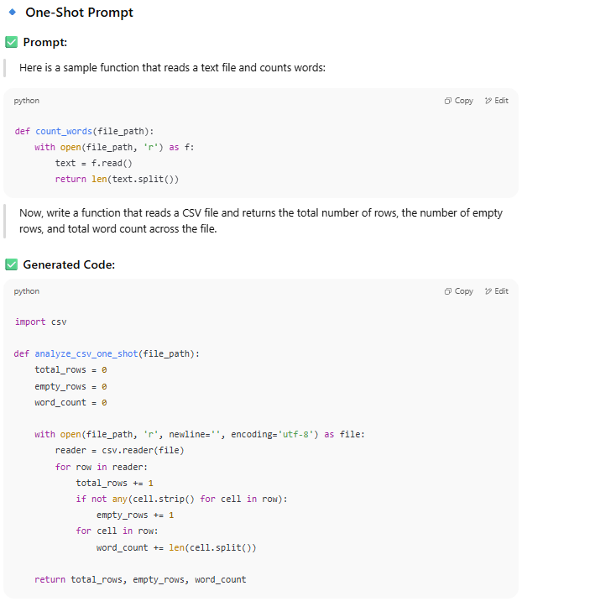

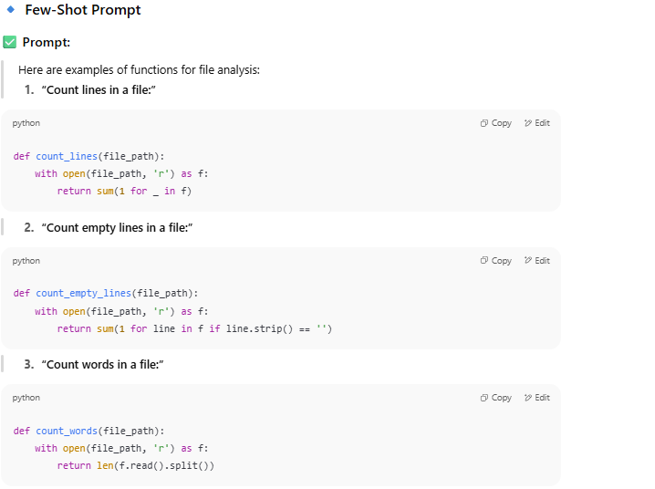

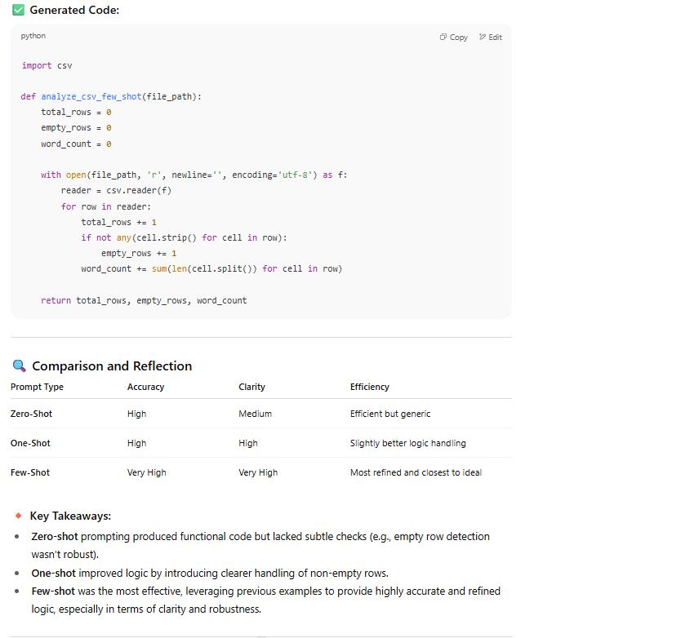

TASK-5

Task #5 – Few-Shot Prompting for Text Processing and Word

Frequency

Objective

Use few-shot prompting (with at least 3 examples) to generate a

Python function that processes text and analyzes word frequency.

Requirements

The function must:

• Accept a paragraph as input

• Convert all text to lowercase

• Remove punctuation

• Return the most frequently used word

Expected Output

• A functional Python script that performs text cleaning,

tokenization, and returns the most common word using only the

examples provided in the prompt

Note: Report should be submitted a word document for all tasks in a

single document with prompts, comments &amp; code explanation, and

output and if required, screenshots

### CODE:

